Stacked Bar-Used when we want to show the contribution of categories
In this case the categories are India and Australia
Code
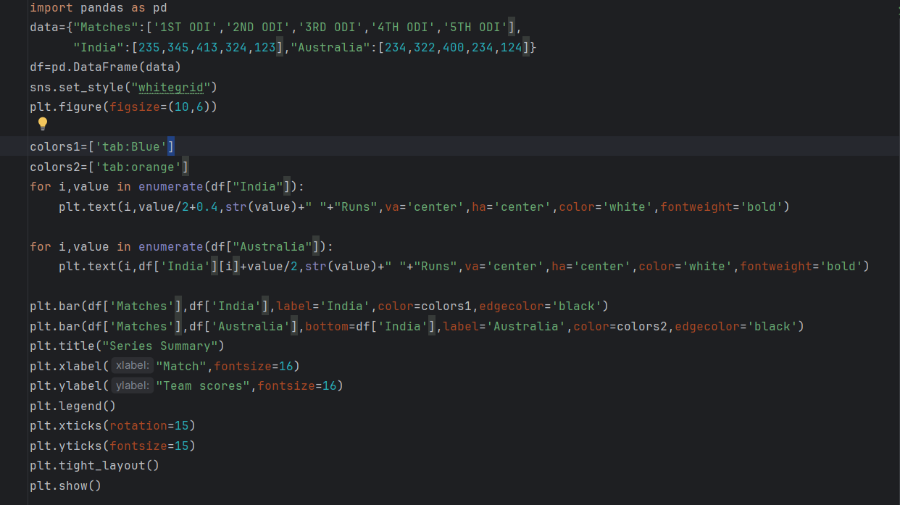
Output
